**Configuring Archiving service line mail:**

1. **Get access to archiving service line 🡪 reference task TASK000001924683**
2. **After getting access you need to follow below steps**

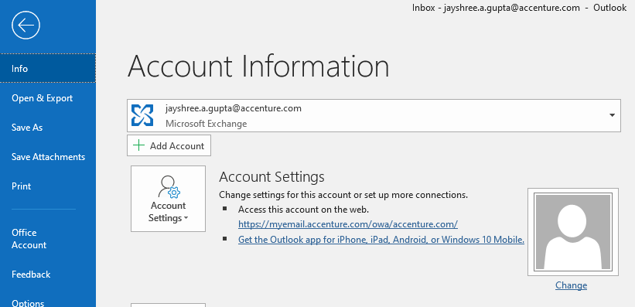

Go to the account setting drop down and select account setting option.

* Click on new and put [archivingserviceline1@bp.com](mailto:archivingserviceline1@bp.com)
* When it will ask for credentials, click another user and put your bp account credentials.
* One more mailbox will be created in your outlook.